TUTORIAL 9
Black-Box & White-Box Testing
Bug ID: BUG-009
Website URL: https://www.saucedemo.com/
Project Name: SauceDemo E-Commerce Website Testing
Tester Name: Riya Dhariwal

TEST CASE EXECUTION
BLACK-BOX TESTING
Test Case 1 – Homepage Review
Test Case ID: SD_TC_01
Input: https://www.saucedemo.com/
Expected Result: The login page should load successfully.
Steps:
- Open Google Chrome.
- Enter the SauceDemo website URL.
- Press Enter.
- Observe the login page.
Screenshot: 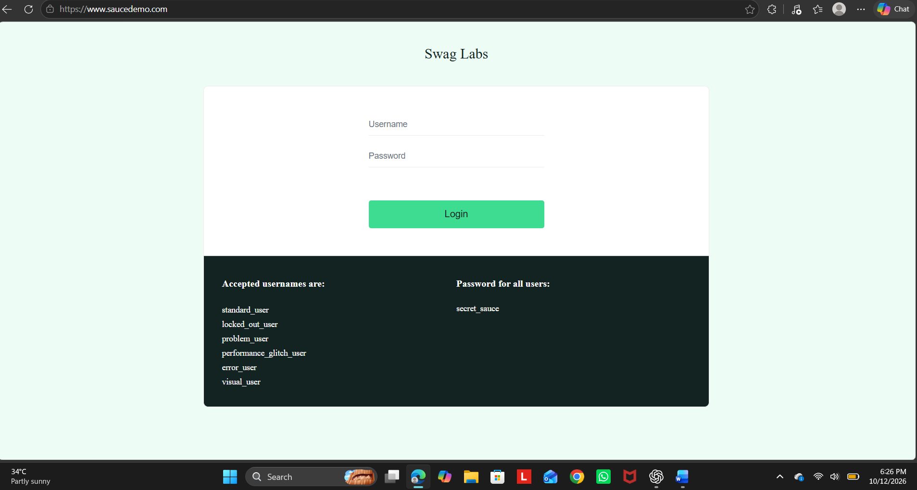
Actual Result: The login page was displayed successfully.
Status: Pass

Test Case 2 – Valid Login
Test Case ID: SD_TC_02
Input: Username: standard_user
Password: secret_sauce
Expected Result:
The user should log in successfully and the Products page should open.
Steps:
- Open the SauceDemo website.
- Enter standard_user in the username field.
- Enter secret_sauce in the password field.
- Click the Login button.
- Observe the resulting page.
Screenshot:

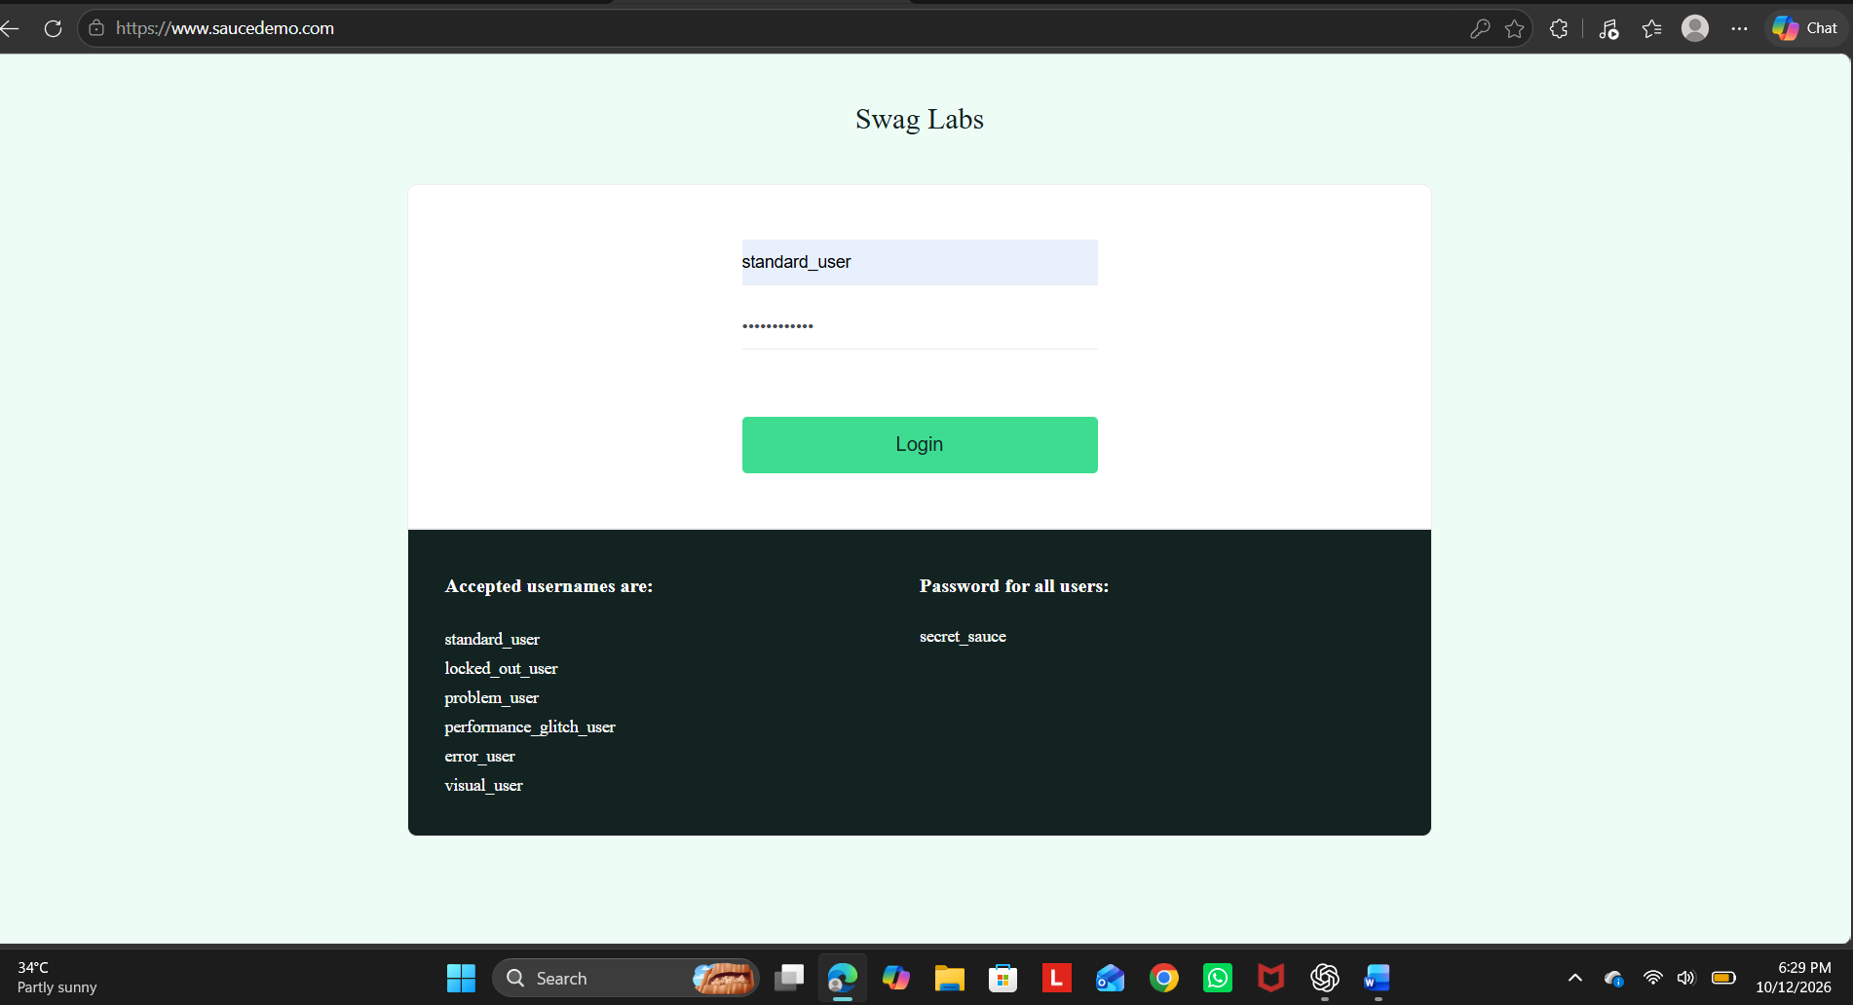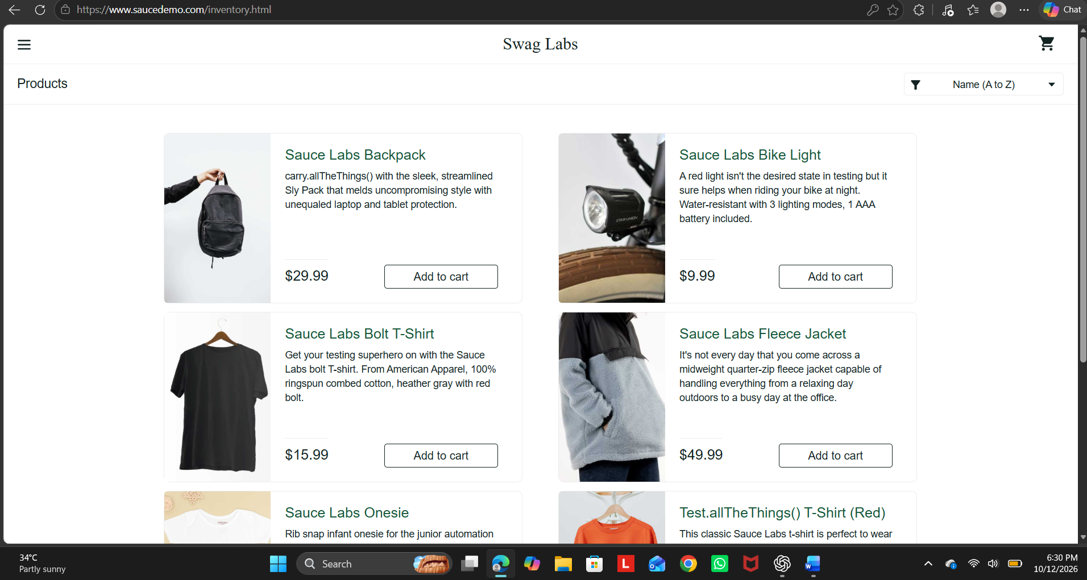Actual Result: The Products page was displayed successfully.
Status: Pass

Test Case 3 – Invalid Login
Test Case ID: SD_TC_03
Input: Username: invalid_user
Password: wrong123
Expected Result: The application should reject the credentials and display an error message.
Steps:
- Open the login page.
- Enter an invalid username.
- Enter an incorrect password.
- Click Login.
- Observe the error message.
Screenshot:
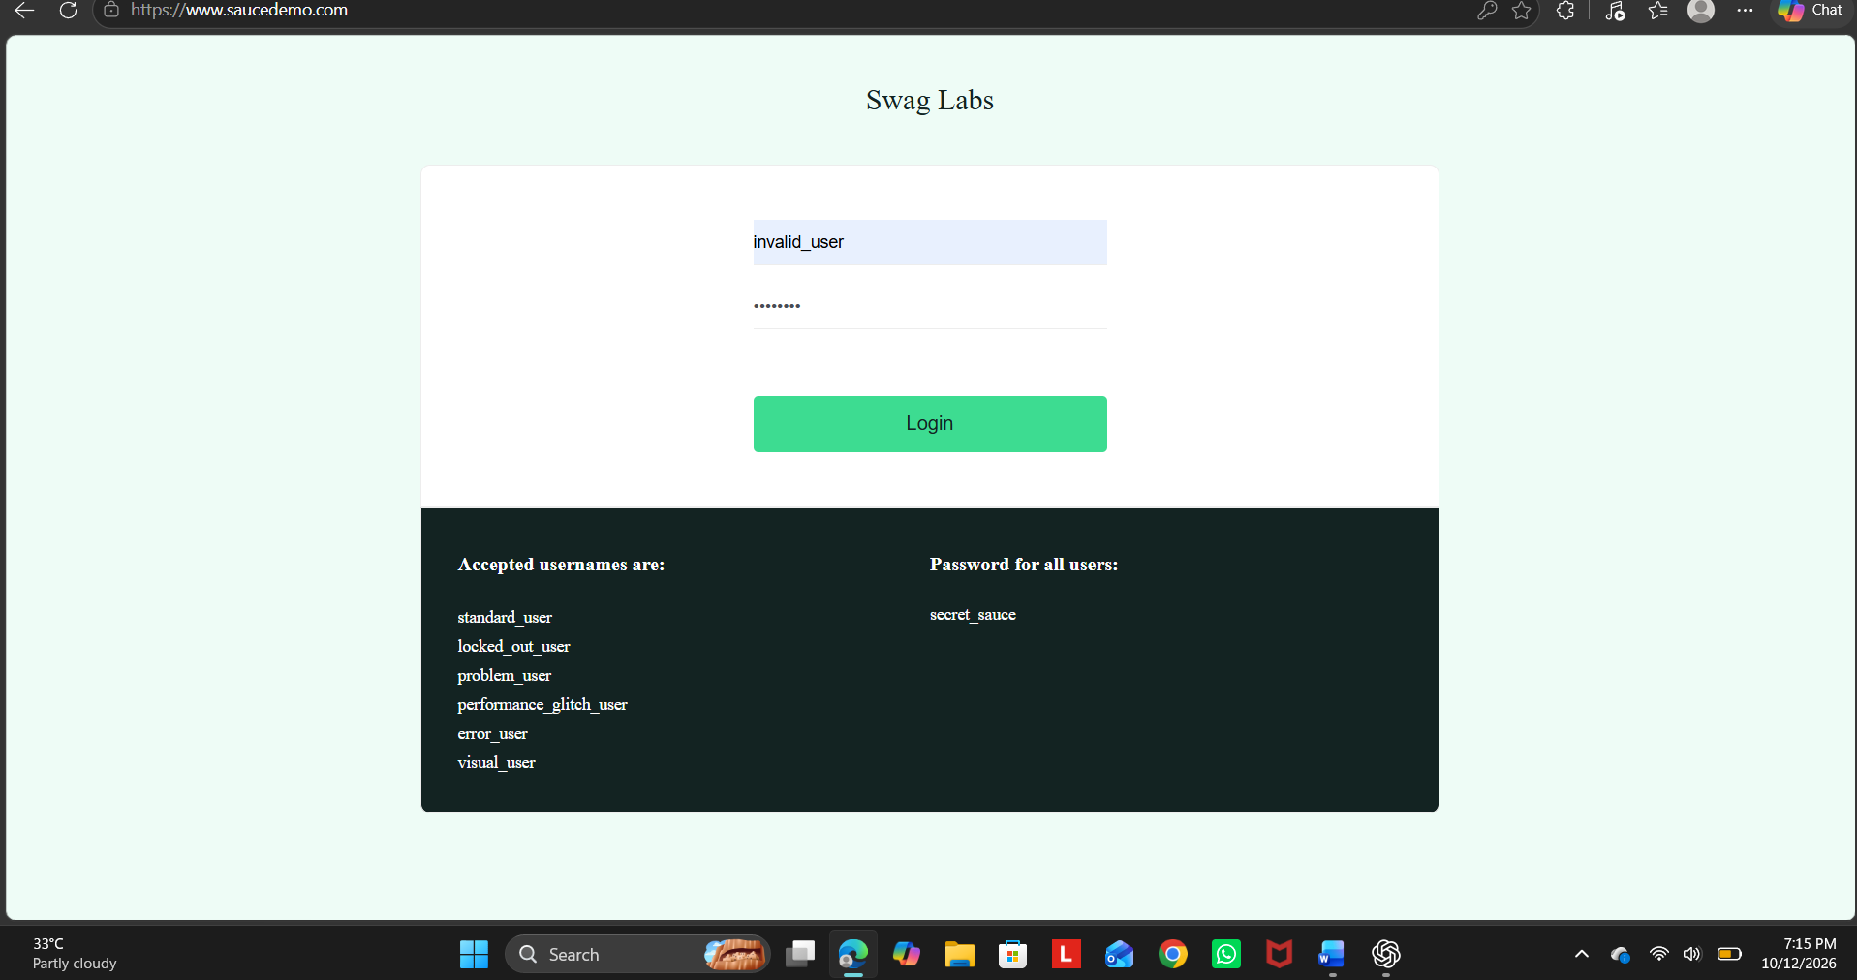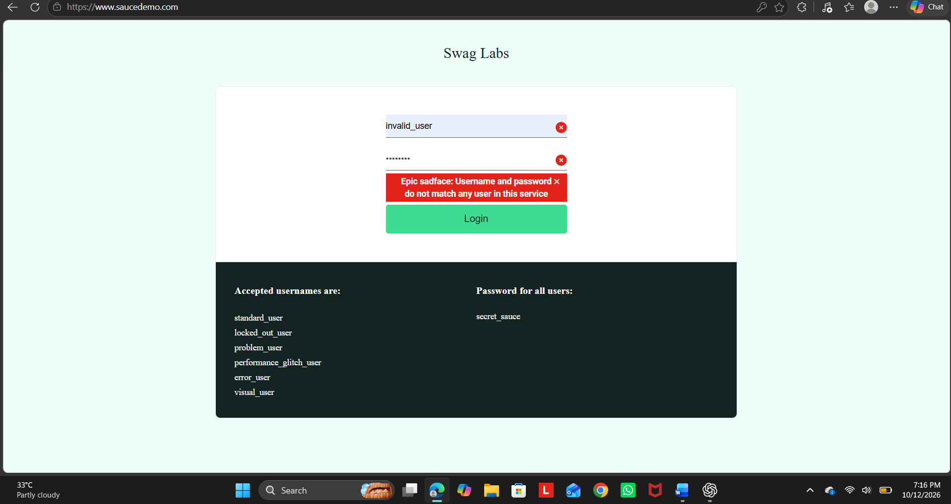Actual Result: The login was rejected and an error message was displayed.
Status: Pass

Test Case 4 – Empty Username Validation
Test Case ID: SD_TC_04
Input: Username: Blank
Password: secret_sauce
Expected Result: The application should display a username validation message.
Steps:
- Open the login page.
- Leave the username field empty.
- Enter the password.
- Click Login.
- Observe the validation message.
Screenshot: 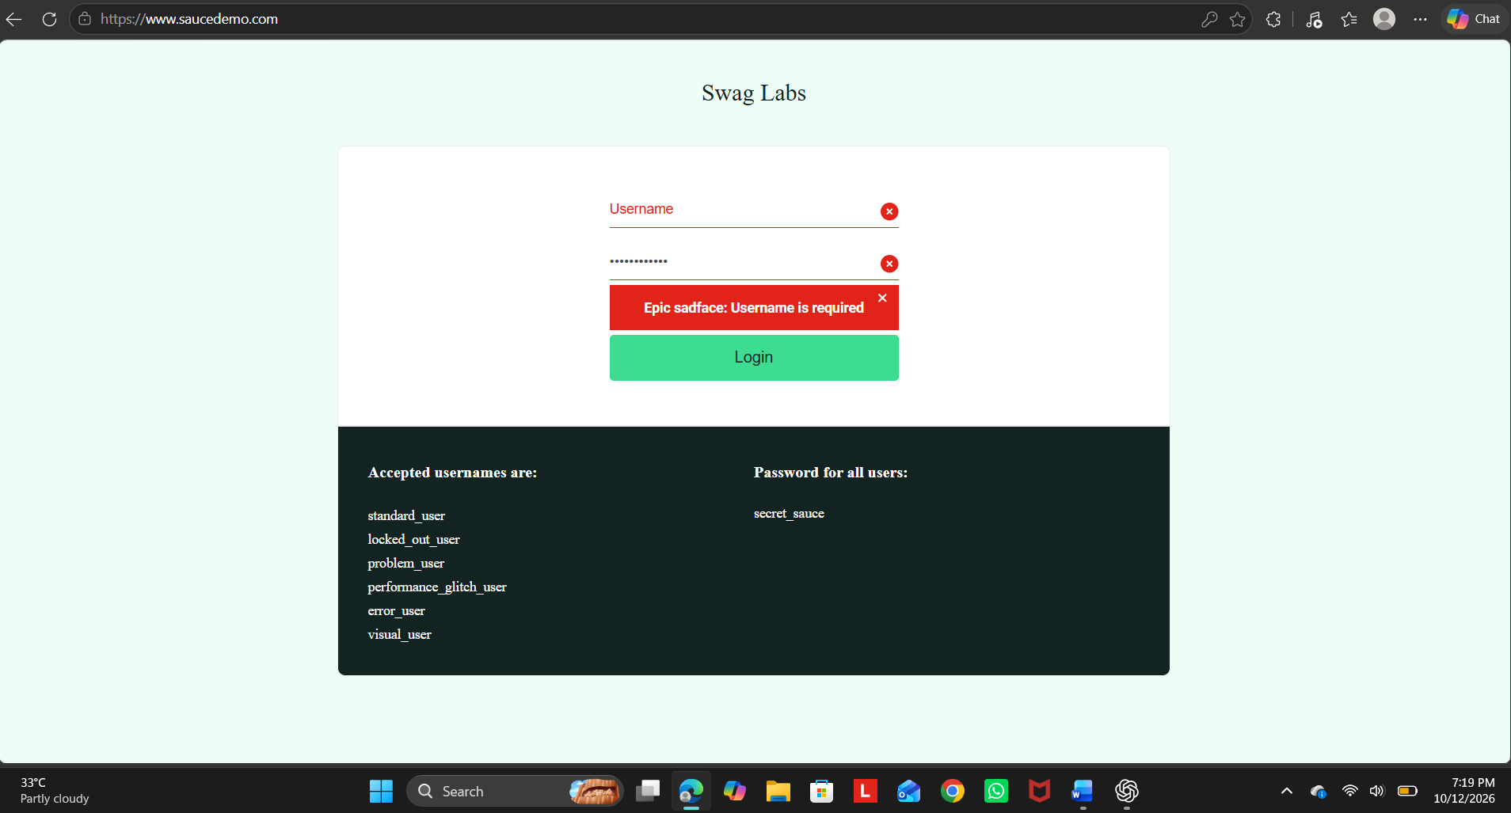Actual Result: The application displayed a validation message requesting a username.
Status: Pass

Test Case 5 – Product Listing
Test Case ID: SD_TC_05
Input: Valid demo login credentials.
Expected Result: Products should be displayed with their names, images, prices, and action buttons.
Steps:
- Log in using valid credentials.
- Observe the Products page.
- Check the product names and prices.
- Verify the product images and Add to cart buttons.
Screenshot: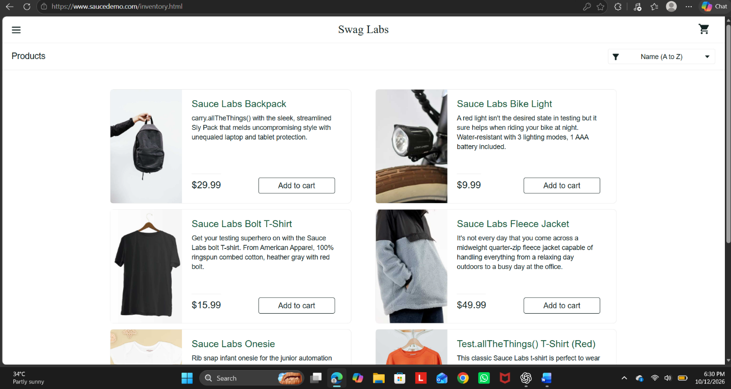
Actual Result: Product details and action buttons were displayed.
Status: Pass

Test Case 6 – Add Product to Cart
Test Case ID: SD_TC_06
Input: Product: Sauce Labs Backpack.
Expected Result: The product should be added to the shopping cart, and the cart badge should display 1.
Steps:
- Log in to the website.
- Locate Sauce Labs Backpack.
- Click Add to cart.
- Observe the shopping cart badge.
Screenshot:
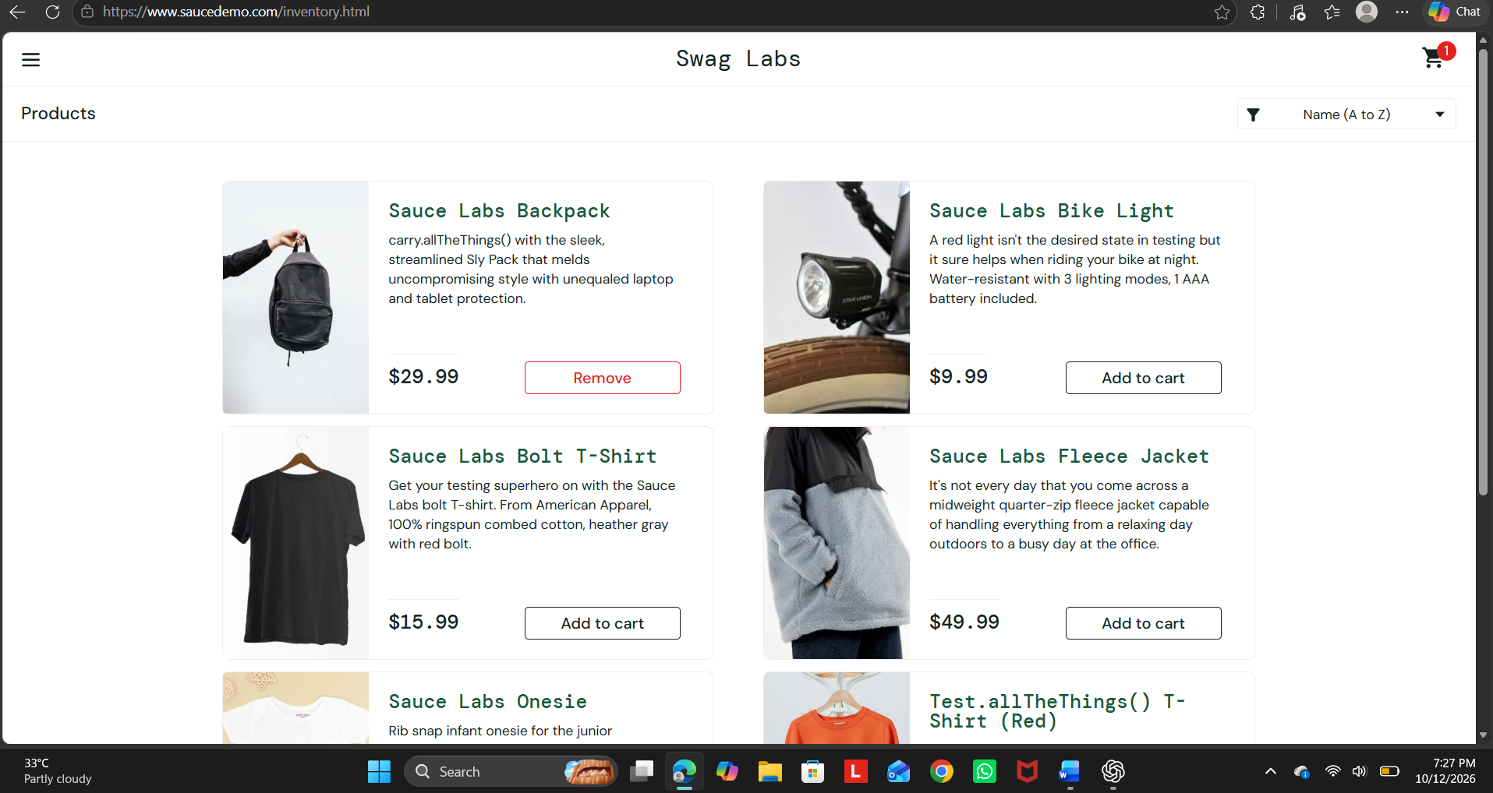Actual Result: The product was added to the cart and the badge displayed 1.
Status: Pass

INTEGRATION TESTING
Test Case 7 – Product and Cart Integration
Test Case ID: SD_TC_07
Input: Sauce Labs Backpack.
Expected Result: The selected product should appear in the cart with the correct name and price.
Steps:
- Log in to SauceDemo.
- Add Sauce Labs Backpack to the cart.
- Click the shopping cart icon.
- Verify the product details and price.
Screenshot:
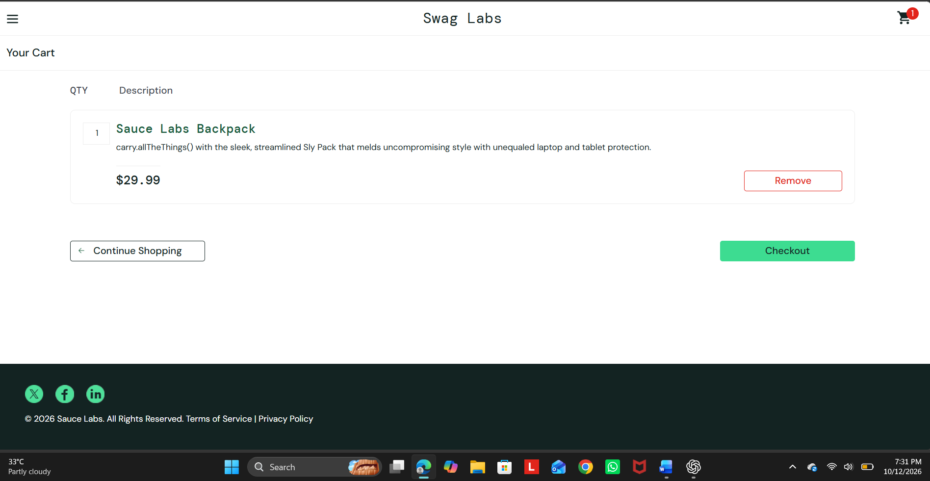Actual Result: The selected product was displayed in the cart with its correct details.
Status: Pass

BLACK-BOX TESTING — CHECKOUT VALIDATION
Test Case 8 – Checkout Validation
Test Case ID: SD_TC_08
Input: First Name: Blank
Last Name: Test
ZIP Code: 380001
Expected Result: The application should prevent checkout from proceeding and display a validation message.
Steps:
- Log in to the website.
- Add a product to the cart.
- Open the cart and click Checkout.
- Leave the First Name field blank.
- Enter the last name and ZIP code.
- Click Continue.
- Observe the validation message.
Screenshot: 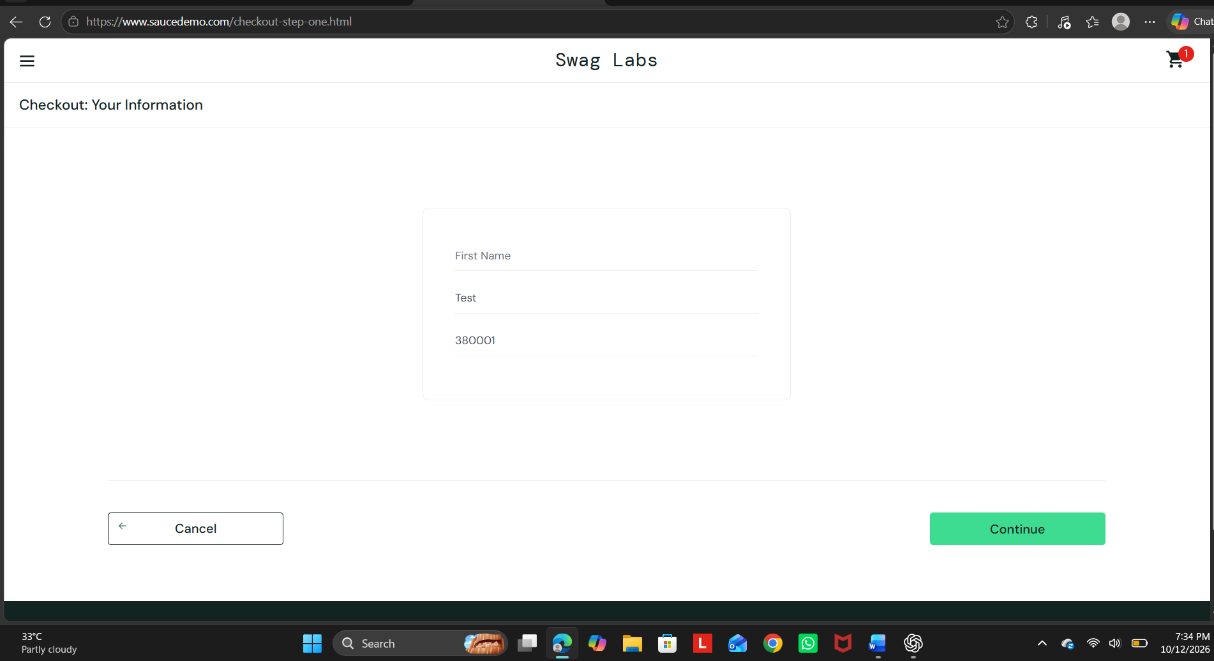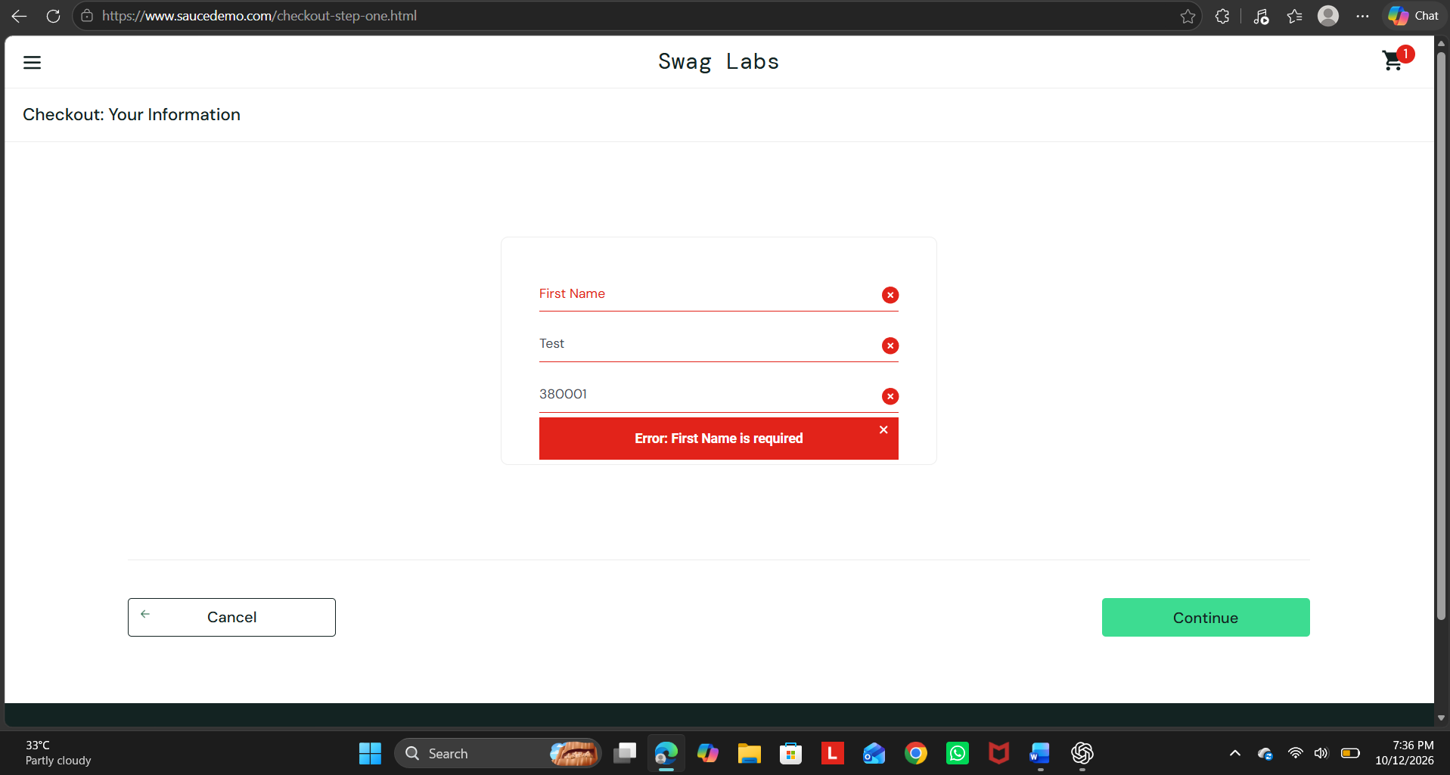Actual Result: The application displayed a required-field validation message and did not proceed to the next checkout step.
Status: Pass

SYSTEM TESTING
Test Case 9 – Complete Checkout
Test Case ID: SD_TC_09
Input: First Name: Riya
Last Name: Dhariwal
ZIP Code: 380001
Product: Sauce Labs Backpack
Expected Result: The checkout process should complete and an order confirmation message should be displayed.
Steps:
- Log in using valid credentials.
- Add Sauce Labs Backpack to the cart.
- Open the cart and click Checkout.
- Enter the first name, last name, and ZIP code.
- Click Continue.
- Review the order summary.
- Click Finish.
- Observe the confirmation page.
Screenshot: 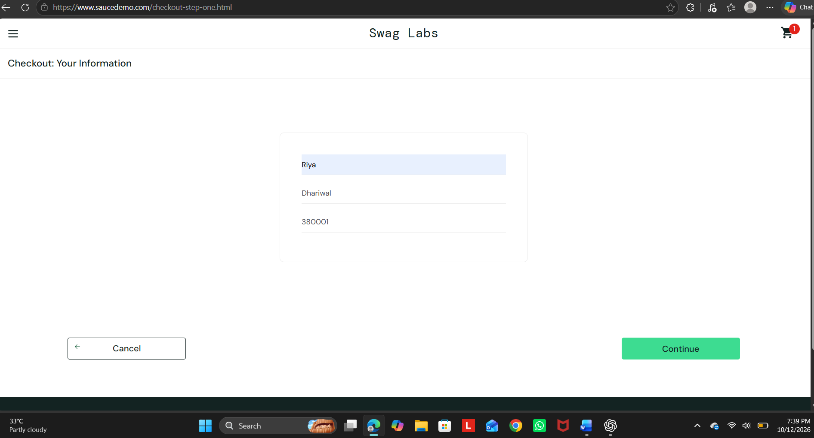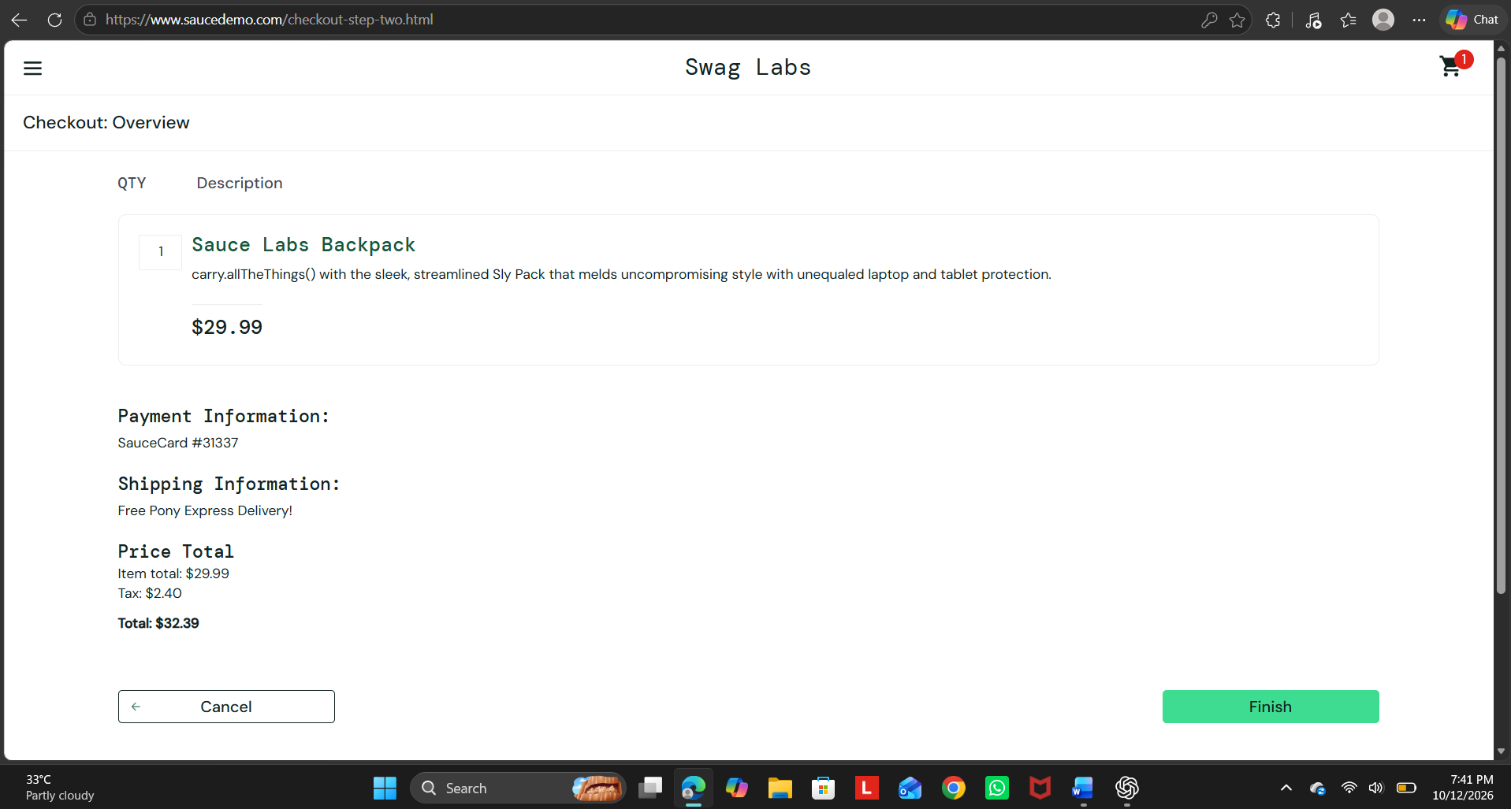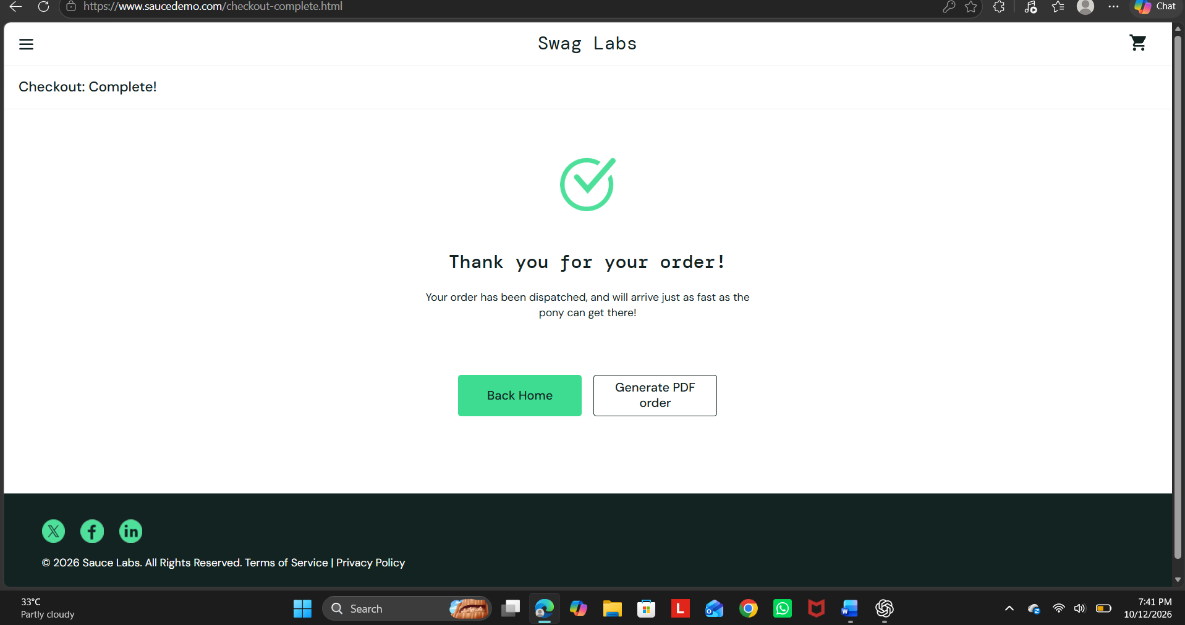
Actual Result: The order confirmation page was displayed successfully.
Status: Pass

WHITE-BOX TESTING
White-Box Testing is performed using the Python Login Module supplied in the Tutorial 9 lab manual. It verifies internal conditions and branches rather than the external website interface.
Test Case 11 – If-Branch Execution
Test Case ID: WB_TC_01
Input: Username: admin
Password: admin123
Expected Result: The program should display Login Successful and Dashboard Opened.
Steps:
- Open Visual Studio Code.
- Create and save the Python file as login_test.py.
- Enter the source code given in the lab manual.
- Run the program.
- Enter the valid username and password.
- Observe the terminal output.
Screenshot: 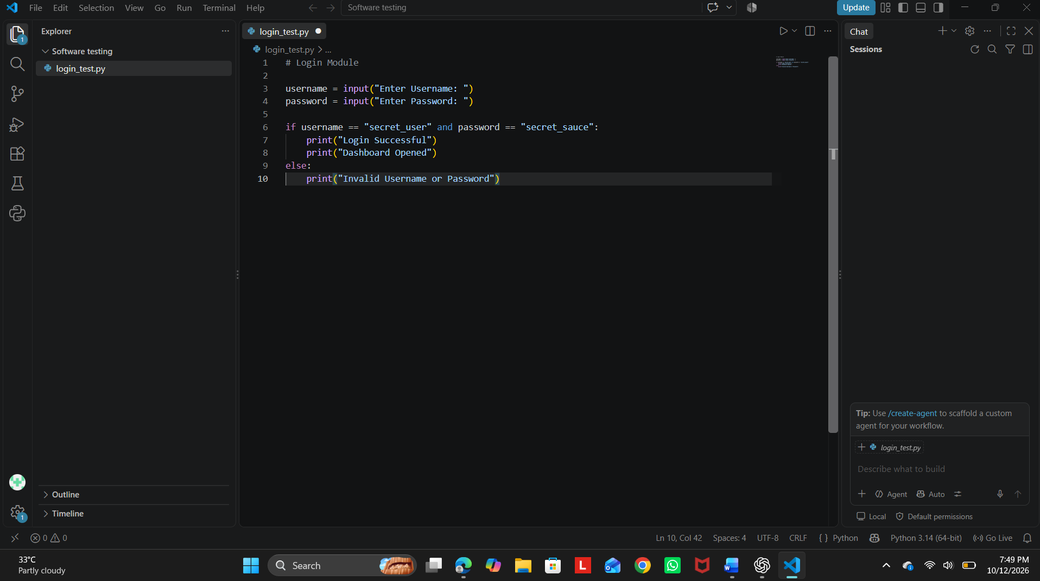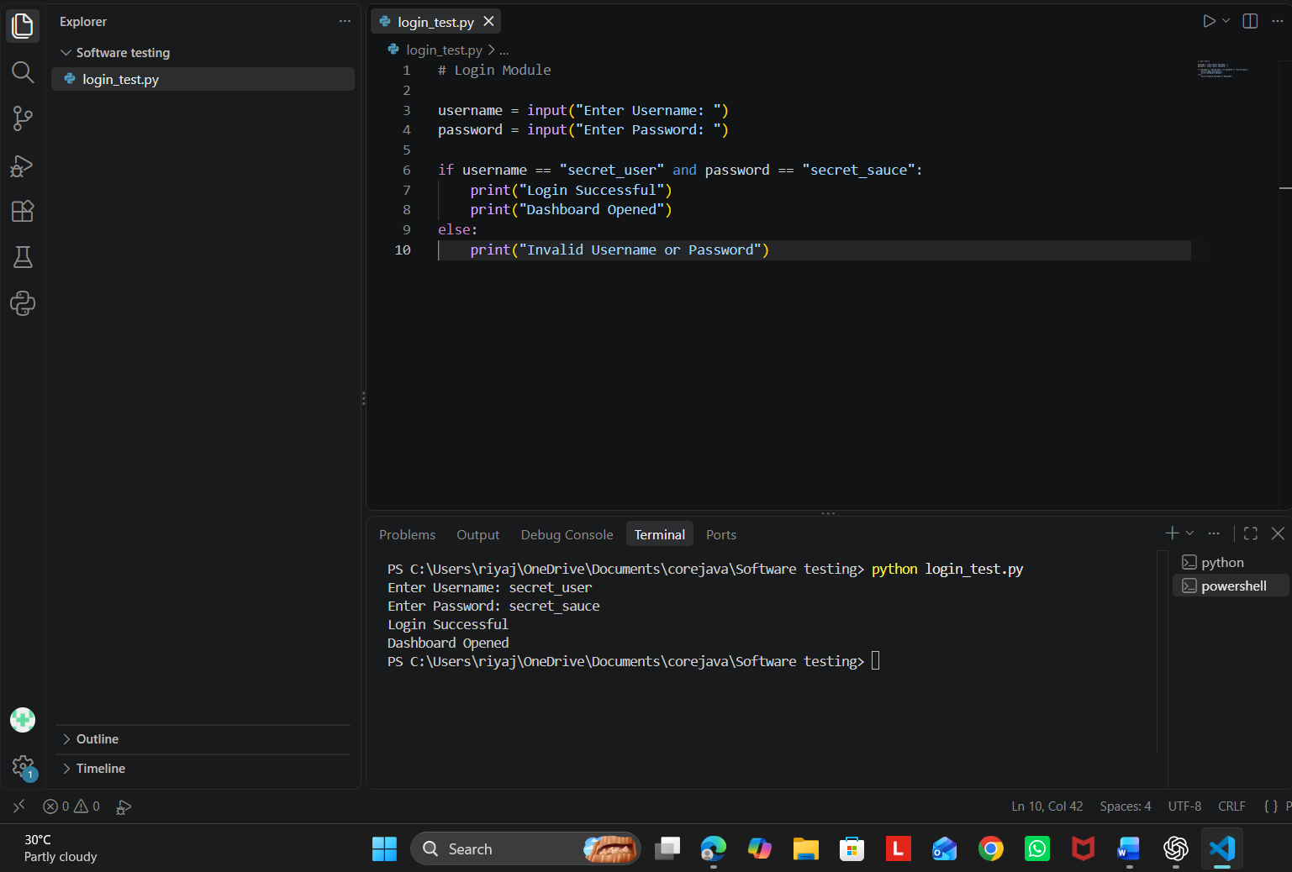
Actual Result: The program displayed Login Successful and Dashboard Opened.
Status: Pass

Test Case 12 – Else-Branch Execution
Test Case ID: WB_TC_02
Input: Username: admin
Password: 12345
Expected Result: The program should display Invalid Username or Password.
Steps:
- Run the Python program again.
- Enter admin as the username.
- Enter 12345 as the password.
- Observe the terminal output.
Screenshot: 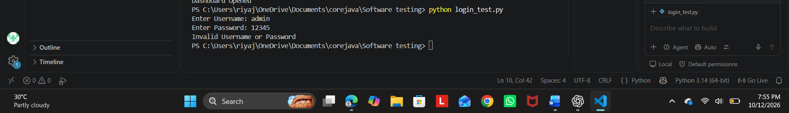Actual Result: The program displayed Invalid Username or Password.
Status: Pass

